BankBot – AI Chatbot for Banking FAQs Using Streamlit

1. Introduction
BankBot is a chatbot web application designed to answer frequently asked banking-related questions. Users can ask queries about account opening, loan interest rates, ATM locations, debit/credit card issues, and bank timings.
The project is built using Python and Streamlit, offering a clean, interactive, and real-time conversational interface. The system also supports multiple chat sessions, similar to AI tools like ChatGPT.

2. Purpose of the Project
Provide automated answers to common banking FAQs.
Reduce workload on customer support staff.
Enable a smooth chat interface using Streamlit.
Allow users to maintain multiple chat threads.
Demonstrate effective state management using Streamlit.
Implement a simple, rule-based chatbot without external APIs.

3. System Architecture
User Input → Streamlit UI → BankBot Logic → FAQ Dataset → Response → UI Display

4. Explanation of the Code
The complete code implements:

5.1 FAQ Knowledge Data
The chatbot uses a predefined dictionary:
faq_data = { "account": "...", "loan": "...", "atm": "...", ... }
This allows instant responses without database calls.

5.2 Response Function
def get_bankbot_response(user_input):
This function:
Converts input to lowercase
Uses keyword matching (e.g., "loan", "atm", "card")
Returns a relevant response from faq_data
Provides a fallback message for unknown queries

5.3 Session State Variables
Streamlit resets the script on each user action. To maintain data, session state variables are required:
all_chats: Stores messages for all chat sessions
current_chat: The chat session currently open
chat_counter: Tracks number of chats created
input_key: Regenerates the input field to clear text
Example:
if "all_chats" not in st.session_state:
st.session_state.all_chats = {}

5.4 Chat Naming Logic
Chat titles are generated automatically from the first user message:
def get_chat_display_name(chat_name):
If no messages exist, the title becomes (Empty Chat).
This makes the chat list behave like ChatGPT’s sidebar.

5.5 Sidebar: Chat Management
The sidebar includes:

Create New Chat
Creates a new chat session and updates session variables.

Display Chat List
Each chat appears as a button:
if st.button(title, key=f"chat_button_{chat_name}"):
A unique key avoids Streamlit's duplicate ID error.

Clear Chat History
Resets the entire session, returning the app to its initial clean state.

5.6 User Input Field
The input field uses a unique key for each refresh:
key=f"chat_input_{st.session_state.input_key}"
This technique forces the input bar to clear after every "Send" action.

5.7 Send Button Logic
if st.button("Send", key="send_btn"):
When clicked:
User message is added to chat history
Bot generates a reply
Both messages get stored
input_key increments to clear input
st.rerun() refreshes the UI
This replicates a real-time chat behavior.

5.8 Chat Display Section
Messages are shown in the conversation area with icons:
You:
BankBot:
Using Streamlit Markdown formatting provides a clean and readable chat layout.

6. Features of the System

Fast, real-time chatbot interaction

Multiple chat sessions like ChatGPT

Chat titles based on user's first message

Auto-clearing input field

Predefined FAQ responses

Clean and user-friendly UI

Reset all chats with one click

7. Benefits of Using Streamlit
No HTML/CSS/JS needed
Real-time UI updates
Simple state management
Easy deployment on Streamlit Cloud
Ideal for prototypes and chat interfaces

8. Issues Faced & Solutions

Issue 1: Duplicate Button ID Error
Cause: Multiple sidebar buttons had the same label
Fix:key=f"chat_button_{chat_name}"
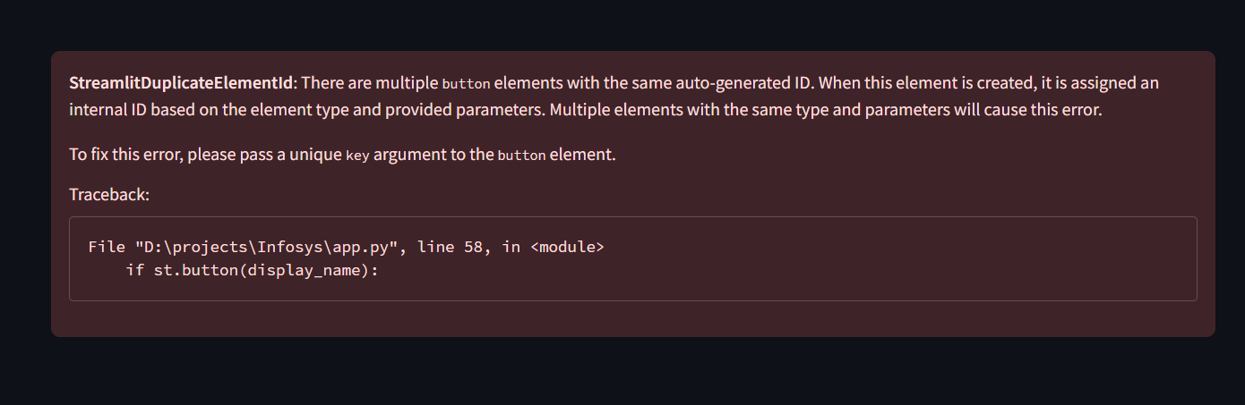
Streamlit automatically assigns internal IDs to widgets.
If two buttons have the same label, like:
Two chats both titled "hi"
Or two "(Empty Chat)"
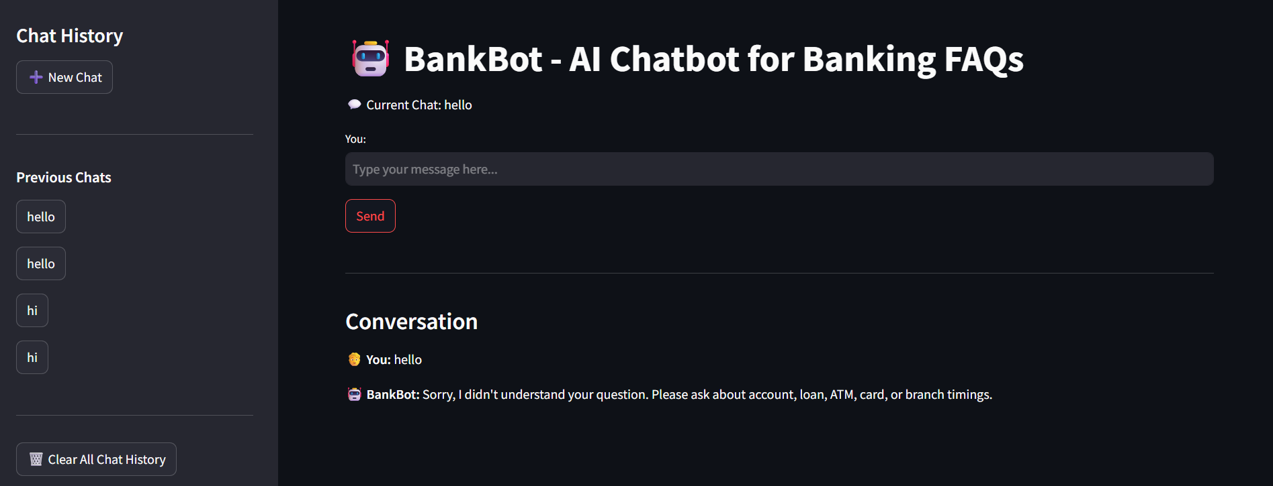

Issue 2: Input Field Not Clearing
Cause: Streamlit does not allow modifying widget state directly
Fix: Use incremental key:
key=f"chat_input_{input_key}"
and regenerate widget on rerun.
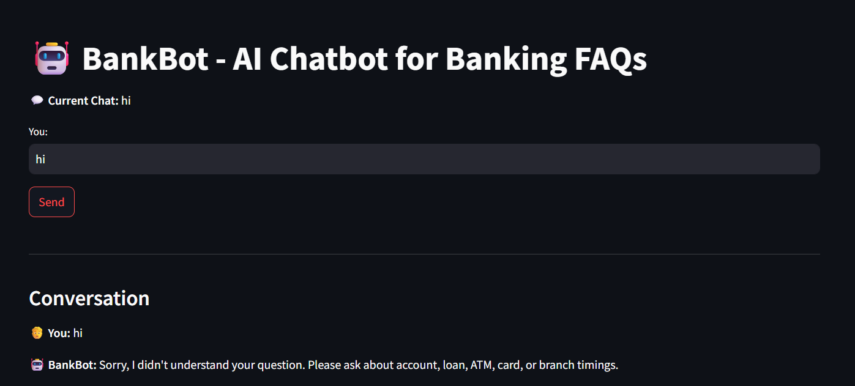

Issue 3: Chat Resets Accidentally
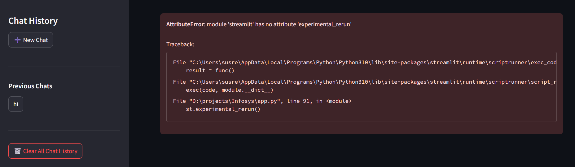
Solution: Initialize all session variables before use.

9. Testing Summary
Test Case | Input | Expected Output
Chatbot responds to loan query | "Loan rate" | Returns loan details
Unknown question | "Hi" | Returns fallback
New chat creation | Click "New Chat" | Empty chat opens
Clear chats | Click delete all | Chat history resets
Input clearance | After send | Input becomes empty

10. Conclusion
This project successfully demonstrates how Streamlit can be used to create a functional chatbot interface. By integrating Python logic, session states, dynamic widget keys, and clean UI, BankBot provides a simple yet effective system to answer banking FAQs.
It is a strong foundation for future enhancements such as NLP models, backend database support, chatbot personality, or multi-language responses

